***Algorithmic Trading System Integration Test***

Algorithmic Trading Software

2023-12-06

Version 1.1

Authors: Jacob Rawlings,Jake Fischer**,** Alan Abdollahzadeh, Devon Volberg, William Blake, Benjamin Carrier, Vanessa Dubouzet, Dakota Flath, Parker Green, Yuan Hu, Jacob Labelle, Isaac Lengacher-Bergeron, Dominic Presch, Dylan Soares, Jaeden Soukoroff

**Revision Sheet**

| Revision | Date | Brief Summary of Changes |
| --- | --- | --- |
| Version 1.0 | 2023-11-30 | Baseline document draft |
| Version 1.1 | 2023-12-06 | Updated based on feedback, added new section based on Automation |
|  |  |  |

**1. INTRODUCTION 1**

**2. CLONED PROJECT DIRECTORY 1**

**3. TABLE CREATION 1**

**4. INSERTION TESTING 2**

**5. TABLE DECONSTRUCTION 3**

**6. TEST RESULTS 4**

**7. AUTOMATION 4**

# INTRODUCTION

The integration test for the Algorithmic Trading System (ATS) is used to ensure proper functionality of the system before new system releases are made. The test is written as bash script, testing required scripts and their outputs. The following document explains how the integration test is implemented.

# CLONED PROJECT DIRECTORY

A clone of the project directory needs to be made to ensure proper functionality. The test requires the use of static test output files for database insertion. This means that file paths in the insertion scripts must be changed for test data to be used. Since the configuration of data collection scripts is dynamic, the size of generated output will also be dynamic, hence the need for test output that never changes.

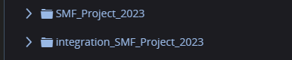

Figure 1 - Cloned project directory on the server

# TABLE CREATION

In order to not interfere with data being collected on the system, the database tables need to be cloned to ensure that test data is not combined with real data. Two files are made, *create_integration_db.sql,* used to create table clones with different names, and *create_integration_triggers.sql,* used to create clones of the triggers needed for proper system function.

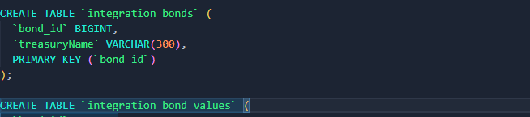

*Figure 2 - create_integration_db.sql example*

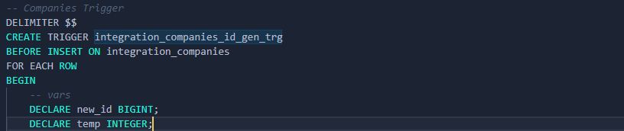

*Figure 3 - create_integration_triggers.sql example*

This is done by running the following commands at the start of the bash script. (See *Figure 4)*

**

*Figure 4 - Database creation*

# INSERTION TESTING

Each data insertion script is run through the same testing procedure:

Data insertion is tested by:

* Running each script to insert test data



*Figure 5 - Historical stock insertion*

* Counting all rows in the associated table after insertion



*Figure 6 - Counting rows from integration_historical_stock_values*

* Checking equality with the expected number of rows (Number of entries in the test output)
* Write the results of that test to the integration test log

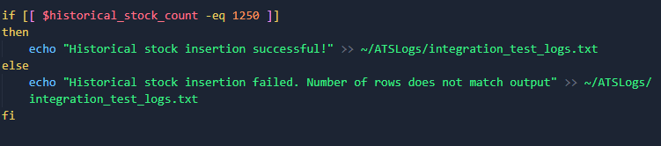

*Figure 7 - Checking equality with expected number of rows, and writing results to test log*

# TABLE DECONSTRUCTION

Once all scripts have been tested, it is important to drop all tables associated with the integration test so they will not interfere with the real environment.

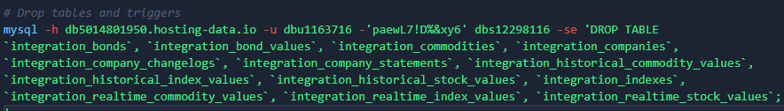

*Figure 8 - Deconstructing the tables, along with the triggers.*

# TEST RESULTS

All test results will be written to *~/ATSLogs/integration_test_logs.txt.* An example output is shown in figure 9

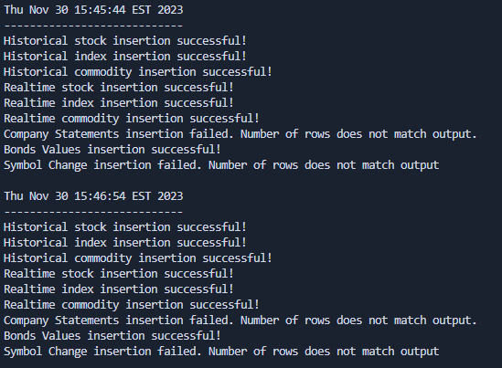

*Figure 8 - Example output from the log files.*

The above results show examples for both passing and failing tests. The company statements and symbol change tests failed because of missing output files in this case.

# AUTOMATION

At this time, fully automating the integration test for the entire ATS isn't viable due to varying table retrievals from the API, making it challenging to update the bash script with precise row counts for the if statements.

However, testing for the correct format and fields across queries is feasible, except for historical queries where using a fixed date range will result in identical results. Fortunately, some insertion tests with fixed row counts can still be automated by setting up a CRON job to run them periodically.